

Quarterly report
  - 1 July to 30 September 2026

© Commonwealth of Australia 2026
ISBN: 978-1-923278-67-7
This publication is available for your use under a Creative Commons Attribution 4.0 International licence, with the exception of the Commonwealth Coat of Arms, the Australian Centre for Evaluation logo, photographs, images, third party materials, materials protected by a trademark, signatures and where otherwise stated. The full licence terms are available from https://creativecommons.org/licenses/by/4.0/legalcode.

Use of Australian Government material under a Creative Commons Attribution 4.0 International licence requires you to attribute the work (but not in any way that suggests that the Australian Government endorses you or your use of the work).
Australian Government material used ‘as supplied’
Provided you have not modified or transformed Australian Government material in any way including, for example, by changing the Australian Government text; calculating percentage changes; graphing or charting data; or deriving new statistics from published Australian Government statistics – then the Australian Government prefers the following attribution:
Source: The Commonwealth of Australia, Australian Small Business and Family Enterprise Ombudsman.
Derivative material
If you have modified or transformed Treasury material, or derived new material from those of the Treasury in any way, then Treasury prefers the following attribution:
Based on The Commonwealth of Australia data, Australian Small Business and Family Enterprise Ombudsman.
Use of the Coat of Arms
The terms under which the Coat of Arms can be used are set out on the Department of the Prime Minister and Cabinet website (see www.pmc.gov.au/government/commonwealth-coat-arms).
Other uses
Enquiries regarding this licence and any other use of this document are welcome at:
Manager
Communications and Media Team
Australian Small Business and Family Enterprise Ombudsman
15 Moore Street
Canberra City ACT 2601
Email: media@asbfeo.gov.au

In the spirit of reconciliation, the Australian Small Business and Family Enterprise Ombudsman acknowledges the Traditional Custodians of country throughout Australia and their connections to land, sea and community. We pay our respect to their Elders past and present and extend that respect to all Aboriginal and Torres Strait Islander peoples.

Contents
Ombudsman’s message 1
Key activities 3
Assistance 3
Advocacy 3
Engagement 4
Assistance 5
New subsidised Alternative Dispute Resolution (ADR) service 5
Seeking help early when disputes arise 5
How we’ve helped 6
Quarterly statistics: signals from small business dispute activity and engagement 7
Digital platforms reshape the dispute landscape for small business 7
Disputes increase for small businesses in construction 8
Case management outcomes 8
Industry codes 9
Tax Concierge Service (TCS) 10
Legal Support Service 10
Advocacy 11
Proportionate, risk-‍based regulation 11
Addressing barriers to business dynamism 11
Digital adoption: Artificial Intelligence (AI), Cyber Security and Privacy 12
Merchant card surcharging ban 12
Engagement 13
Quarter highlights 13
Card surcharging ban 13
Stakeholder engagement 15
Stakeholder meetings 15
Presentations and webinars 16

Ombudsman’s message


Australia’s small businesses continue to face a challenging operating environment. Across the country, I hear from business owners managing rising costs, workforce shortages, changing customer expectations and growing compliance obligations. Many are doing everything they can to keep their businesses moving forward while supporting their staff, customers and communities. Those pressures are real, and they continue to shape the conversations we have every day.
This quarter, our focus remained on helping small businesses navigate challenges, advocating for better outcomes and making it easier to access the information and assistance they need. Behind every phone call, enquiry or case is a business owner looking for guidance, seeking a solution or simply trying to understand their options. During the quarter, we received 1,258 calls to our contact centre and actively managed 833 cases.
We continued to strengthen the assistance available to small businesses experiencing disputes. This included introducing a new subsidised Alternative Dispute Resolution service and expanding our Legal Support Service, giving eligible small businesses greater access to affordable dispute resolution options when they need them.
The case studies featured in this report highlight the real-world issues small businesses face and the difference early assistance can make. They show how timely intervention can help resolve disputes, overcome obstacles and keep businesses moving forward. Digital platform disputes were particularly prominent this quarter, accounting for almost half of the new cases we actively managed. This reinforces the importance of accessible and effective pathways for small businesses to resolve problems when they arise online.
Every interaction with a small business helps build a clearer picture of the issues affecting the sector. Insights from our assistance work not only help us respond to immediate concerns but also inform our broader advocacy. We focused on issues including regulation, digital technologies, artificial intelligence, privacy, cyber security and unfair trading practices. Our work included contributing to the Productivity Commission’s inquiry into Reducing Barriers to Business Dynamism and completing our review of white tape, with the final report provided to the Minister for Small Business. We continued to advocate for proportionate, risk-based regulation and guidance that works for small business.

A significant focus this quarter was helping small businesses understand and prepare for the merchant card surcharging reforms that took effect on 1 October 2026 following the Reserve Bank of Australia’s decision to remove surcharges on eftpos, Mastercard and Visa card payments. We delivered a targeted 3-phase communications campaign to provide timely information and help small businesses prepare for the change with confidence.
Working with government agencies, regulators, industry associations, chambers of commerce, and culturally and linguistically diverse (CALD) and First Nations organisations, we extended the reach of clear and consistent information through trusted networks. This collaboration also provided opportunities to highlight the practical implications of the reforms for small businesses.
Alongside this work, we advocated strongly for small businesses following the Australian Taxation Office’s (ATO) proposed changes to credit card payments, highlighting the impact that removing this option too quickly could have on businesses already managing significant cash flow pressures.
I welcomed the Australian Government’s decision to ensure the ATO continues accepting credit card payments until 30 June 2027, giving small businesses valuable breathing room while longer-term arrangements are considered. Our advocacy will continue through the ATO’s consultation on what comes next. We will be actively involved, bringing the experiences of small businesses to the table and advocating for payment arrangements that are practical, accessible and reflect the realities of running a small business.
Engagement is central to what we do and remained an important part of our work this quarter. Through meetings, roundtables, conferences, webinars and industry events across Australia, we continued to connect with small businesses, their representatives, regulators and government agencies. These conversations help us identify emerging issues and ensure small business perspectives are heard by those developing the policies, regulations and decisions that affect them.
Small businesses are at the heart of Australia’s economy and communities, and we will continue to listen, advocate and work to achieve better outcomes for them.
Lynda McAlary-Smith
Australian Small Business and Family Enterprise Ombudsman

Key activities

Assistance
- We were contacted for information and assistance 1,258 times through calls to our new contact centre provider, the Victorian Department of Energy, Environment and Climate Action (DEECA), which commenced answering our assistance phone line 1300 650 460 on 1 July 2026.
- We introduced a new subsidised Alternative Dispute Resolution (ADR) service. Under the new service, we may offer to subsidise an ADR process where a small business is in dispute with another business. This service significantly reduces the cost for small businesses to participate in ADR and is provided to maximise their opportunity to resolve their dispute without having to go to court.
- We expanded our Legal Support Service following a successful pilot. We are now able to offer up to 4 hours of legal support where an ADR process is contemplated, or the small business would otherwise benefit from legal support to clarify issues or understand possible next steps towards resolving their dispute. Eligible small businesses are offered the service and if they accept, we ask that they make a copayment of $100 and we pay the remainder of the legal practitioner’s fee.

Advocacy
This quarter, we focused our advocacy on:
- proportionate and risk-based regulation which reflects the capacity constraints and operating realities of small businesses, including highlighting the cumulative compliance burden of regulation and business-to-business ‘white tape’.
- reducing barriers to business dynamism through our active engagement with the Productivity Commission inquiry.
- digital adoption, with a focus on support for small businesses to effectively and safely use digital technologies, including Artificial Intelligence.
- continuing to raise awareness within government of the growing impact of digital platform disputes on small businesses and the need for platforms to provide timely and effective resolution.
- helping small businesses prepare for the Reserve Bank of Australia’s (RBA) Payments System Board card surcharging changes by providing practical information and educational materials through government, industry and community networks.
- advocating for the ATO to continue accepting credit card payments, with the subsequent decision to extend this option until 30 June 2027, giving small businesses more time while longer-term arrangements are considered.

Engagement
It has been a highly productive and insightful quarter of engagement and advocacy, with ongoing collaboration across governments, parliamentarians and small business advocates to ensure the experiences, challenges and priorities of small businesses are heard and considered in decision-making.
This quarter we:
- Delivered a package of practical, actionable information and education materials to help small businesses understand the RBA Payments System Board card surcharging changes that came into effect on 1 October.
- Published and promoted a new resource for small businesses who are ‘Navigating Disputes under the National Disability Insurance Scheme’.
- Promoted the Legal Support Service, Tax Concierge Service and our broader assistance functions, alongside our advocacy work, data insights, and information resources. We also recognised key events and days of significance, including National Family Business Day, NAIDOC Week, Scams Awareness Week, and R U OK? Day.
- Continued to strengthen our social media presence, achieving growth in followers, engagement, impressions and reach across all channels.
- Published 3 newsletters, chaired one National Small Business Communications and Media Network meeting, participated in the Federal Regulatory Agency Group outreach and engagement meeting, and contributed to 3 Top End Regional Small Business Network meetings.
- Promoted our services with 6 editorial features in Convenience World, Kochie’s Business Builders and Australia Lottery and Newsagency Association (ALNA) magazines online and/or in print.
- Participated in a range of national, state and regional events, including the Queensland Small Business Month Expo in Brisbane, the Queensland Small Business Friendly Conference in Rockhampton, and the Franchising and Start Your Own Business and Small Biz Week Expo in Melbourne.
- Continued to improve website accessibility through content consolidation and updates to support compliance with the Web Content Accessibility Guidelines 2.2 and the Digital Service Standard. We also published new educational resources on the card surcharging ban, essential business updates, and navigating disputes under the National Disability Insurance Scheme (NDIS).
- Delivered 7 presentations, participated in 13 webinars, panels, forums, and roundtables, expanding our reach and engagement with small business stakeholders across Australia.
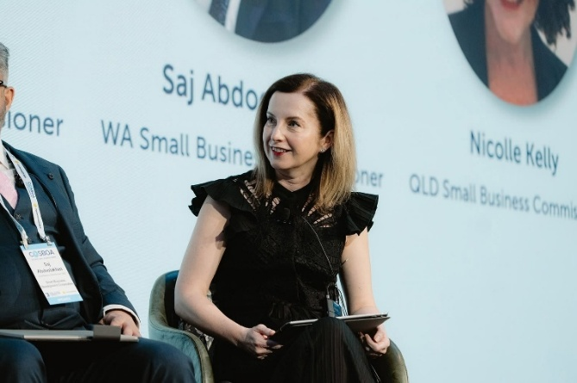
Lynda McAlary-Smith at the COSBOA National Small Business Summit.

Assistance

New subsidised Alternative Dispute Resolution (ADR) service
This quarter, we started offering a new subsidised ADR service to help eligible small businesses resolve disputes without progressing to formal legal action.
The service provides access to independent ADR practitioners, with participating businesses each making a co-payment of $250-$500, depending on whether the length of the mediation. We pay the remainder of the ADR practitioner’s fee. By reducing the financial barriers that can prevent small businesses from pursuing ADR, the initiative is intended to increase access to timely, practical and commercially focused outcomes.
The service supports businesses involved in commercial disputes who are willing to engage in good faith and explore negotiated resolutions. ADR assists parties to identify common ground, improve communication and work towards mutually acceptable outcomes while preserving valuable business relationships.
The introduction of the service followed an open market tender process for the panel of ADR practitioners. It is still in its very early stages, and several offers to use the service have been made. Eligibility criteria apply which are available on our website. We will continue to monitor uptake and outcomes as the service becomes established.

Seeking help early when disputes arise
Many small business disputes become more difficult to resolve as time passes. By the time some business owners seek assistance, positions have become entrenched, commercial relationships have deteriorated, and enforcement action may have already commenced.
Early engagement creates more opportunities to resolve a dispute and preserve important business relationships. Whether the issue relates to payment, contracts, leasing or another commercial matter, having open discussions and seeking assistance before a situation escalates helps parties identify practical solutions and avoid unnecessary costs.
A range of support services are available to help small business owners navigate challenges. We can assist small businesses understand dispute resolution options and, where suitable, offer access to our legal support service or subsidised ADR service. Small business owners experiencing financial difficulty can also access free and independent financial counselling support through the Small Business Debt Helpline.
While every dispute is different, seeking assistance early can improve the likelihood of reaching a workable outcome and help businesses focus on continuing to operate, grow and maintain valuable commercial relationships.

How we’ve helped

Informal engagement resolves dispute
A regional transport business sought our assistance after ongoing issues with vehicle tracking devices supplied under a service agreement. Tracking devices were installed across several fleet vehicles; however, 2 stopped working within a short period.
Despite repeated contact with the supplier over several months, the business said the issues remained unresolved. Concerned about the impact on operations, it engaged an alternative provider to install replacement devices and returned the original devices to the supplier.
The supplier maintained that the business remained bound by the contract and was required to continue making payments until the end of the agreement term. The business argued it should not be responsible for ongoing charges because the devices were not functioning and repeated requests for assistance had not resulted in a resolution.
After unsuccessful attempts to resolve the matter directly, including through a letter of demand, the business contacted us for assistance.
We engaged with the supplier and facilitated discussions between the parties. Following our informal engagement, the supplier agreed to provide a full refund, resolving the matter without formal legal action.

Digital platform dispute resolved preventing data loss
A small business approached us for assistance after a dispute with a digital platform provider over software subscription fees and access to critical business data.
The business had entered into a premium software subscription but later considered that a lower-cost package would have been more suitable for its needs. When financial difficulties emerged, the parties became involved in a dispute over outstanding subscription fees, future service arrangements and the potential deletion of the businesses data.
The business advised that negotiations with the provider had stalled and that its data was at risk of being permanently deleted. We engaged with both parties and encouraged constructive discussions to identify practical options for resolving the dispute. By facilitating communication at a critical stage of the matter, we helped the parties work towards a mutually beneficial outcome.
As a result of our engagement, the parties reached an agreement without the need for ADR. The business retained access to its data and was able to continue using the platform on terms better aligned to its operational needs.
The provider subsequently thanked us for our involvement, noting our assistance was constructive and helped both parties reach a positive outcome.

Quarterly statistics: signals from small business dispute activity and engagement
Demand for information and assistance has remained elevated over recent quarters, with digital platform disputes accounting for a significant proportion of new cases. Our data provides a practical view of the issues small business bring to us and the circumstances in which they seek assistance.
Findings in this section reflect analysis of cases requiring dedicated case management and should be read as indicators of observed patterns, not measures of overall prevalence in the small business population.
Together, these insights highlight how the nature and impact of disputes can vary across different parts of the small business landscape.

Digital platforms reshape the dispute landscape for small business
Digital platform disputes have become an increasingly prominent part of the issues brought to us. Our case managers assisted with 403 new digital platform disputes this quarter, accounting for 48% of all new cases.
While dispute volumes across many traditional categories have fluctuated over time, the rapid growth of digital platform disputes represents a significant shift in the profile of matters coming to us. This quarter, these disputes were most commonly in the professional, scientific and technical services and retail trade industries.
For small businesses experiencing problems with a digital platform, accessing timely, human assistance can be difficult, particularly where support pathways rely heavily on automated or self-service processes. At the same time, digital platforms often are important channels for reaching customers and conducting business, meaning simply leaving a platform may not be a practical option when problems arise. The prominence of these disputes highlights the importance of accessible and effective pathways for small businesses to resolve issues quickly.
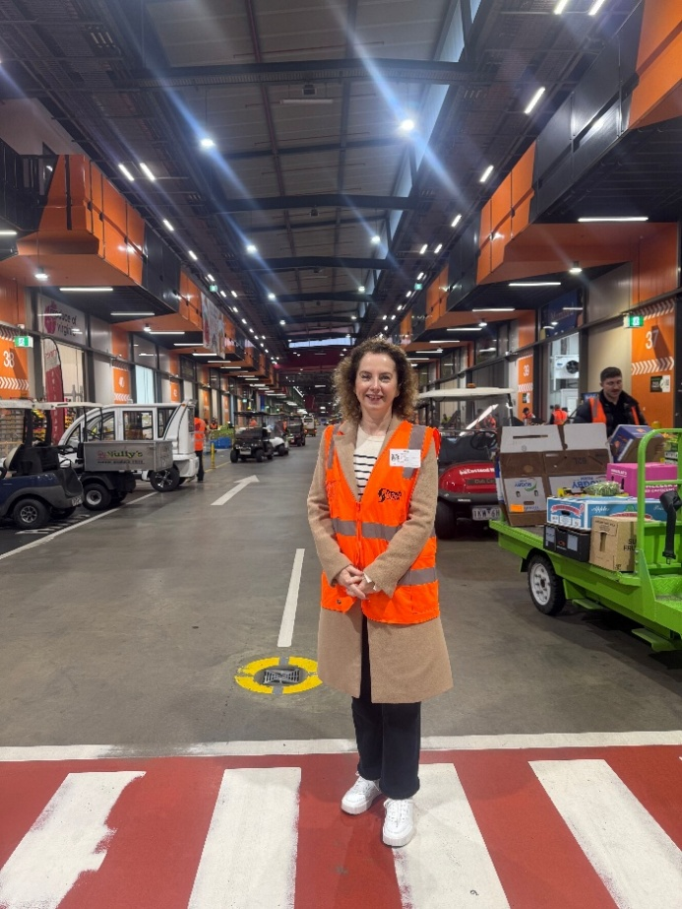
Lynda McAlary-Smith at the Melbourne market.

Disputes increase for small businesses in construction
We assisted with 79 new disputes involving construction businesses this quarter, compared with 39 in the same quarter last year. While the numbers remain relatively small, the increase is notable, with payment disputes featuring prominently among the matters raised with us.
For small construction businesses, problems getting paid can have effects beyond the individual transaction. Businesses still need to meet wages, supplier costs and other expenses while waiting for money owed to them, putting pressure on cash flow and their ability to meet other commitments.
Our assistance data does not tell us whether payment disputes are increasing across the construction sector more broadly. However, the experience of businesses seeking our assistance highlights the importance of timely payment to small businesses, particularly where they have limited capacity to absorb delays while continuing to meet their own financial commitments.
This quarter, we had:
- 1,258 calls to our contact centre
- 833 new cases that we actively managed.
Digital platform disputes are the most common type of dispute where we provide one-to-one support. This quarter, they accounted for 48% of new actively managed cases. Other common types of disputes were payment (26%), contract (11%) and franchise disputes (5%).

Case management outcomes
- 71% of cases required active case management support, including providing information to help resolve the dispute (noting that calls to our Information Line are not included)
- 24% were referred to a more appropriate agency (usually relevant Small Business Commissioner, or alternative government agency)
- 5% were referred to an ADR practitioner.
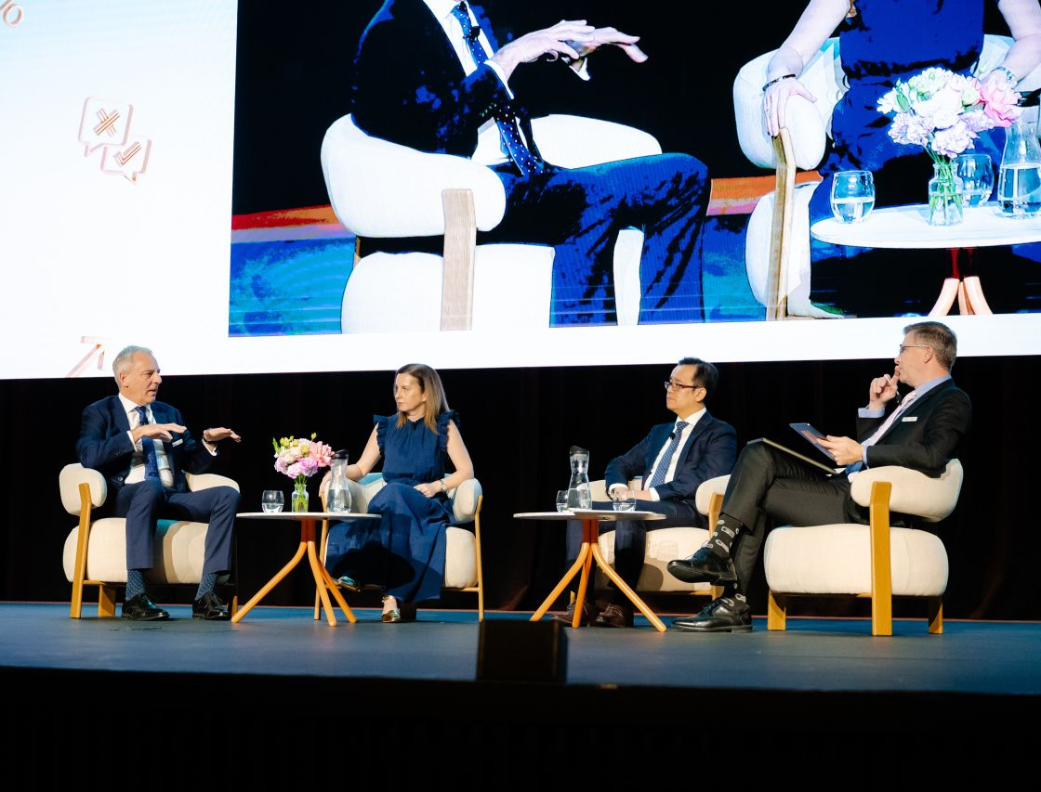
Lynda McAlary-Smith at the Tax Summit with Tim Sandow (President, Tax Institute), Duy Dam (Deputy Tax Ombudsman), and Scott Treatt (Chief Executive Officer, Tax Institute).

Industry codes

Franchising Code of Conduct
As part of our responsibilities under the Franchising Code of Conduct, we:
- keep lists of arbitrators, conciliators and mediators for the Code or franchise agreements
- appoint arbitrators, conciliators
and mediators
- receive information about disputes that are being, or have been, dealt with under the Code or a complaint handling procedure of a franchise agreement
- regularly provide to the Minister statistical information relating to disputes under the Code or complaint handling procedures
- publicise names of parties who refuse to engage in or withdraw from ADR.
While not a responsibility under the Code, as part of our broader role we provide general information about franchising on our website, including guidance on entering and exiting a franchise.
This quarter we provided franchise participants with information relating to the use of the mandatory dispute resolution process under the Code. We also arranged ADR processes and appointed independent ADR practitioners to disputes as requested. This included helping 42 new franchise disputes with a dedicated case manager.

Horticulture Code of Conduct
As part of our responsibilities under the Horticulture Code of Conduct, we:
- maintain a compiled list of mediators and horticulture produce assessors
- appoint a mediator or horticulture produce assessor upon request.
This quarter we continued to provide participants with information relating to the use of the mandatory dispute resolution process under the Code. We also managed ADR processes and appointed independent ADR practitioners to disputes when requested.
This quarter there were no new cases under the Code requiring dedicated case management.

Oil Code of Conduct
As part of our responsibilities under the Oil Code of Conduct, we:
- advise the Minister on dispute resolution under the Code
- can make a non-binding determination about a dispute
- appoint a mediator
- comment on advice provided by a mediator.
This quarter we continued to provide participants with information related to the use of the mandatory dispute resolution process under the Code. We also managed ADR processes and appointed independent ADR practitioners to disputes when requested.
This quarter there were no new cases under the Code requiring dedicated case management.

Dairy Industry Code
As part of our responsibilities under the Dairy Industry Code, we:
- keep lists of arbitrators and mediators
- appoint arbitrators and mediators
- request and receive information about disputes under the Code.
This quarter we continued to provide participants with information relating to the use of the mandatory dispute resolution process under the Code. We also managed ADR processes and appointed independent ADR practitioners to disputes when requested.
This quarter there were no new cases under the Code requiring dedicated case management.

Food and Grocery Code
As part of our responsibilities under the Food and Grocery Code, we are required to keep lists of ADR practitioners who can provide services of mediation or arbitration for the purposes of this Code (including for a grocery supply agreement).
This quarter we did not receive any requests for the list of ADR practitioners in relation to disputes under the Code.

Tax Concierge Service (TCS)
Our TCS continued providing small businesses with information and assistance about a range of taxation matters. This quarter, we received 11 new matters with a dedicated case manager.
The TCS worked with the small businesses and the ATO to help issues to be addressed and/or referred matters to independent tax lawyers for subsidised advice about appealing negative decisions.

Legal Support Service
Our Legal Support Service assists small businesses navigate dispute resolution. Since its implementation in March 2025, the service has been offered 167 times to eligible small businesses, with over half of the offers accepted.
Specialist legal advice is available to unrepresented small businesses at up to 2 stages of the dispute resolution process for a small co-payment:
- Stage 1 can assist a small business understand the issues in dispute and whether ADR may be an appropriate way to attempt to resolve them.
- Stage 2 offers access to a legal practitioner who can provide strategic advice to assist the small business to prepare for the ADR process. This includes helping the business prepare documentation, understand what to expect during ADR, identify outcomes the business is seeking, discuss negotiation options and adopt a resolution mindset.

Advocacy
This quarter, we continued to bring a small business perspective to policy development processes, providing insights on their experiences and the issues they face.
Some key areas of focus are outlined below and our submissions to public consultations available on our website.

Proportionate, risk-‍based regulation
We continued to advocate for policies and regulations that are proportionate and risk-based, with compliance requirements that consider the administrative capacity and operating realities of small business. This advocacy was illustrated in our submission for consultations on:
- modern slavery in supply chains
- minimum tax on discretionary trusts
- Privacy Act reforms
- unfair trading practices.
Our submissions emphasised the importance of avoiding unnecessary duplication and administrative burden, including where obligations extend through supply chains. In these circumstances, proportionate, consistent compliance requests and practical, tailored guidance and tools can reduce the regulatory burden on small businesses while maintaining the underlying policy objectives.
The importance of proportionate, risk-based regulation was also a key theme that emerged in our review into the prevalence and impact of white tape on small business. ‘White tape’ refers to reporting obligations passed down by larger businesses in business-to-business relationships as they seek to shift regulatory compliance and risk onto smaller businesses in contract or supply chain arrangements. To reduce white tape costs, we advocate for streamlining and reducing duplication in reporting, providing suppliers with tailored guidance that is clear and actionable, and managing procurement risk in ways that are proportionate to a projects and individual supplier’s risk profile.

Addressing barriers to business dynamism
Throughout the quarter, we actively engaged in the Productivity Commission’s (PC) inquiry into Reducing Barriers to Business Dynamism. In our July submission, we noted the diverse characteristics of small businesses and particular challenges faced by those in regional and remote areas, and highlighted regulatory complexity, business skills and capabilities, and Australia’s insolvency system as key barriers to small business entry, expansion and exit.
We also provide a small business perspective at several meetings and roundtables hosted by the PC, including at a small business roundtable we helped the PC organise with members of our Policy Network.

Digital adoption: Artificial Intelligence (AI), Cyber Security and Privacy
We continued our advocacy on small business digital adoption through submissions to consultations on AI, cyber security and Privacy Act reforms.
We emphasised that the adoption of digital technology creates significant productivity, efficiency and innovation benefits for small businesses, while also introducing risks as businesses share more of their data and are increasingly being targeted by scams and cyber security threats, often due to lower levels of cyber security maturity and limited specialist resources.
To maximise the opportunities of digital adoption while responding to business risks, we advocate for initiatives that:
- consolidate the available resources and support through a single online hub specifically designed for small business, supported by a concierge-style advisory service
- reflect how small businesses prefer to engage with and access Government support, including providing practical tools such as decision-making frameworks, flowcharts, checklists and relatable case studies – disseminated through trusted peer networks
- take a broad view of how related regulatory obligations interact with one another, and the overall impact this has on small businesses
- enhance pathways to restitution and dispute resolution when small businesses experience digital harms online and through digital platforms.

Merchant card surcharging ban
Following the RBA’s Payments Board announcement of reforms to ban card surcharging, reduce interchange fees and improve price transparency, the Government announced that we would help small businesses understand the changes ahead of 1 October 2026.
Since August, we have provided targeted communications and practical guidance to help small businesses prepare for the changes. Our information and education materials have focused on the practical actions small businesses can take, including understanding merchant service costs, reviewing pricing practices, educating staff, updating point-of-sale systems, removing surcharge signage, as well as directing them to additional information and support.
We have worked closely with the ACCC, Treasury and RBA in developing these materials, and will continue to support small businesses through implementation.

Engagement

Quarter highlights
We continued to engage extensively with small businesses and their representatives across Australia to better understand the challenges and opportunities shaping their operating environment. Through targeted outreach and engagement activities, we increased awareness of our services and support offerings while strengthening relationships with key stakeholders. These efforts have fostered constructive collaboration with policymakers, industry associations and governments at all levels, supporting our shared objective of improving outcomes and operating conditions for small businesses.

Card surcharging ban
We delivered a targeted, 3-phase communications campaign to help small businesses understand and prepare for the card surcharging changes:
- Phase 1: Raise awareness by explaining what was changing and when.
- Phase 2: Support preparation and action by providing practical guidance and encouraging businesses to review their payment systems, costs, pricing and customer communications before 1 October 2026.
- Phase 3: Support implementation by reinforcing that the changes were in effect and directing businesses to trusted information and support.
The campaign used clear, practical and consistent information supported by a stakeholder kit containing:
- key messages and fact sheet
- frequently asked questions
- newsletter and social media content
- promotional assets
- explainer video.
The kit included ready-to-use content that stakeholders could easily copy, tailor and share through their own channels and networks.
We worked with government agencies, regulators, industry associations and community networks to coordinate and amplify the campaign through social media, a dedicated webpage, electronic communications and trusted stakeholders and industry networks, including Chambers of Commerce and Industry, CALD networks and First Nations small business organisations. This coordinated approach achieved strong reach and engagement across government, stakeholder and our channels.
The card surcharging content also became the strongest-performing post to date across Australian Government and Department of the Prime Minister and Cabinet social media channels (AusGov), as outlined in the performance metrics on the next page.
Furthermore, we advocated for the ATO to continue accepting credit card payments, with the subsequent decision to extend this option until 30 June 2027, giving small businesses more time while longer-term arrangements are considered.

Table 1: Card surcharging performance metrics as at 30 September 2026
Platform | Performance metrics
Australian Government and Department of Prime Minister and Cabinet social media  (Instagram, Facebook, LinkedIn and Threads) | 3,590,686 impressions  23,788 users reached  13,394 engagements (likes, comments, shares and saves)
ASBFEO paid and organic social media*  (LinkedIn, Instagram and Facebook) | 128,296 impressions  75,904 users reached  329 engagements (likes, comments, shares and saves)  7,891 link clicks
ASBFEO webpage  (asbfeo.gov.au/card-surcharging) | 13,423 views
Electronic Direct Mail (EDM)  (EDM sent to ASBFEO newsletter subscribers, National Small Business Communications and Media Network members, policy and advocacy stakeholders, Digital Solutions Program providers and stakeholders, Electorate offices, Chambers of Commerce and Industry, and CALD and First Nations stakeholders) | 4,239 emails sent  1,840 emails opened (43.4% open rate)  1,385 asset clicks
* paid promotion took place between 27 August 2026 to 17 September 2026

Stakeholder engagement
We engaged with a diverse range of stakeholders, including industry associations, regulators, not-for-profit organisations and government agencies, to identify emerging issues and collaborate on initiatives that support small business success.
The Ombudsman participated in a range of roundtables, conferences, forums and networking events, providing insights on key small business matters, promoting our services and strengthening relationships across the small business ecosystem.
Through these engagements, we continued to enhance our understanding of stakeholder priorities and ensure that the perspectives of small businesses are represented in policy and regulatory discussions.

Stakeholder meetings
This quarter, the Ombudsman met with the following organisations to discuss opportunities to improve outcomes for small businesses (listed alphabetically):
- Amazon
- AusPost
- Australian Chamber of Commerce and Industry
- Australian Competition and Consumer Commission
- Australian Financial Complaints Authority
- Australian Financial Security Authority
- Australian Retail Council
- Australian Securities and Investment Commission
- Australian Tax Office
- Beyond Blue
- Business NSW
- Council of Small Business Organisations Australia
- Department of Finance
- Direct Selling Australia
- eBay
- Fair Work Commission
- Fair Work Ombudsman
- Family Business Association
- Master Builders Australia
- National Lotteries and Newsagents Association
- Productivity Commission
- Shopping Centre Council of Australia
- Small Business Association of Australia
- State Small Business Commissioners
- Tax Ombudsman
- Telecommunications Industry Ombudsman.
- Treasury
- UK Small Business Commissioner
- Xero.

Presentations and webinars
This quarter, the Ombudsman delivered presentations and participated in webinars to share insights and raise awareness for our role and services, engaging with:
- Association of Independent Insolvency Practitioners
- COSBOA Small Business Summit
- Financial Counsellors Association – NSW
- Landers & Rogers Legal
- Mortgage and Financial Association of Australia – NSW/ACT
- Resolution Conference
- Tax Institute Summit.
- Smart Company/Creditor Watch.
The Ombudsman/her representatives also appeared at one parliamentary inquiry hearing:
- Joint Committee on Corporations and Financial Services – Inquiry Small Business Insurance.
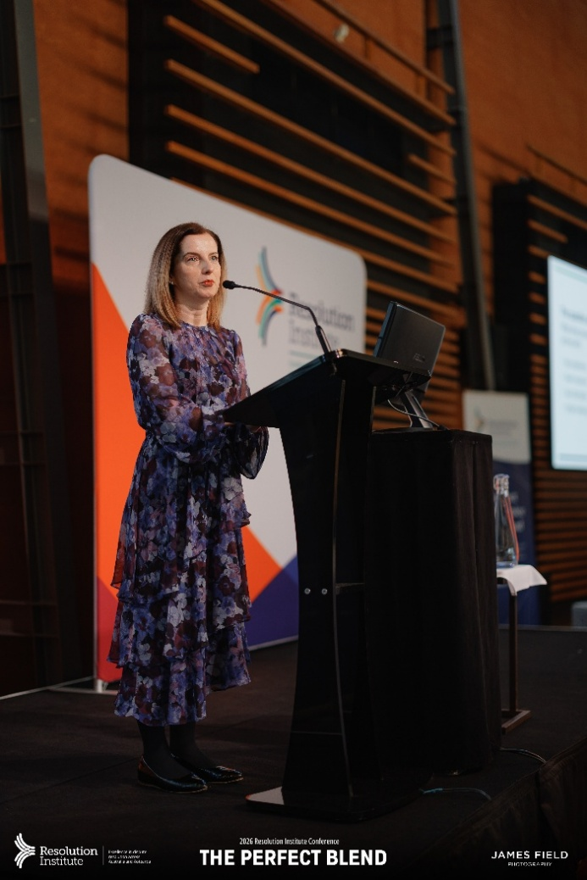
Image: Lynda McAlary-Smith at the Resolution Institute Conference.

