Quarterly report
  - Australian Small Business and Family Enterprise Ombudsman | Quarter 4 – 2016

Contents
Letter to the Minister
Foreword 1
Summary of recent key activities: 1
Outreach 2
Awareness & Education 2
Communications channels 3
Key meetings and events 4
Advocacy 5
Inquiries 5
Research and advocacy issues 6
Legislation, policies and practices impacting small business 6
Assistance 7
Examples of Assistance Provided 9

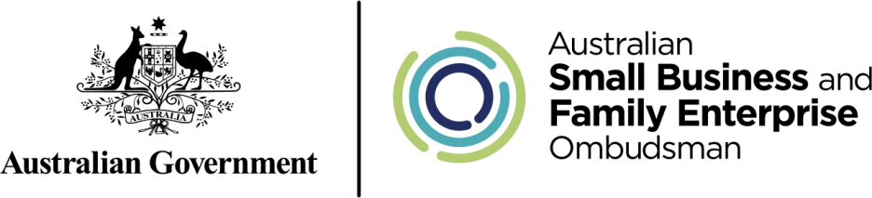

27 January 2016
The Hon. Michael McCormack MP
Minister for Small Business

Dear Minister McCormack
Quarterly report
I am pleased to present you with this quarterly report outlining my outreach and advocacy activities, along with assistance requests from small businesses, during the period 1 October to 31 December 2016, in accordance with the reporting obligations outlined in section 40 of the Australian Small Business and Family Enterprise Ombudsman Act 2015 (Cth).
We have continued to make a difference in the activity

Yours sincerely

Kate Carnell AO
Australian Small Business and Family Enterprise Ombudsman

Foreword
Legislation establishing the first small business and family enterprise ombudsman was introduced to Federal Parliament in 2015. The Australian Small Business and Family Enterprise Ombudsman (ASBFEO) Act 2015 subsequently received Royal Assent in September that same year.
Kate Carnell AO commenced the role of ASBFEO in March 2016. The role of the ASBFEO is to:
- Advocate for small businesses and family enterprises;
- Provide access to dispute resolution services to assist businesses in resolving disputes without resorting to costly litigation; and
- Ensure Government policies take into account the needs of small businesses and family enterprises.

Summary of recent key activities:
This overview provides a brief summary of the ASBFEO’s activities throughout the fourth quarter of 2016.
- Outreach
  - Encouraging debate/consideration among small businesses and family enterprises on a range of issues relevant to their sector in order to shed light on matters impacting their livelihood.
  - Undertaking various media (metro, regional and rural) activity including radio, television and print interviews, social media activity, media releases and articles in trade publications.
  - Participating in meetings and events, while also delivering presentations.
- Advocacy
  - Completed the inquiry into Small Business Loans which investigated the adequacy of the law and practices governing authorised deposit taking institutions in lending to small businesses and presented the final report to the Minister for Small Business, the Hon. Michael McCormack MP on 12 December 2016.
  - Commenced the Ombudsman’s first self-initiated inquiry into payment times and practices in conjunction with the State Small Business Commissioners from New South Wales, Victoria, Western Australia and South Australia. The Council of Australian Small Business, Institute of Public Accountants and the Australian Institute of Credit Management are also participating in the inquiry.
  - A range of advocacy activities were undertaken in relation to legislation, policies and practices that have an impact on small business including superannuation laws, amendments to the Competition and Consumer Act in relation to section 46 (‘the effects test’), procurement and the dairy industry among other issues.
- Assistance
  - The Ombudsman received close to 500 ‘contacts’ through phone and email.
  - The large majority of these were dispute-related enquiries or enquiries requiring general assistance or information.

Outreach

Awareness & Education
The ASBFEO answered questions in relation to/or sought consultation from the small business community on:
  - Small business bank lending practices;
  - The Federal Government’s instant asset write-down;
  - Payment terms and practices;
  - Unfair Contract Terms legislation;
  - Penalty rates; and
  - Pricing transparency in the dairy industry.

The ASBFEO has compiled an Advocacy Agenda that reflects the key priories for the office throughout 2017 and beyond. The Advocacy Agenda will be released early in 2017.

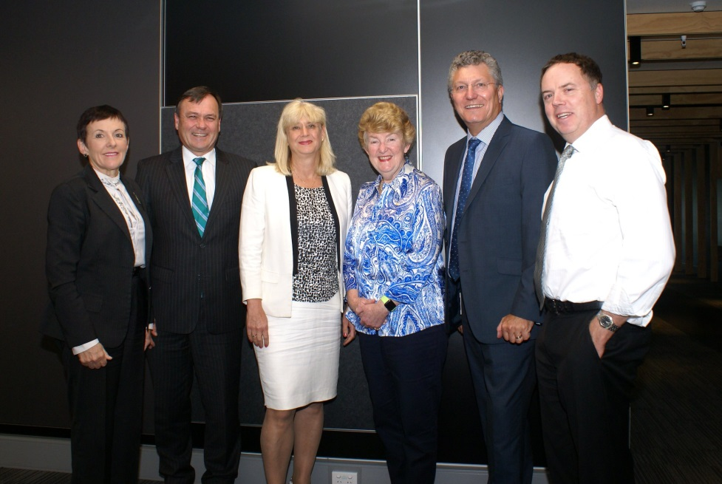
The Australian Small Business and Family Enterprise Ombudsman’s Payment Times and Practices Inquiry was a hot topic during the Small Business Commissioners December meeting in Perth.

Communications channels
During the reporting period, the Ombudsman undertook various media (metropolitan, regional and rural) activity. This included radio, television and print interviews, along with social media activity, media releases and articles in trade publications.
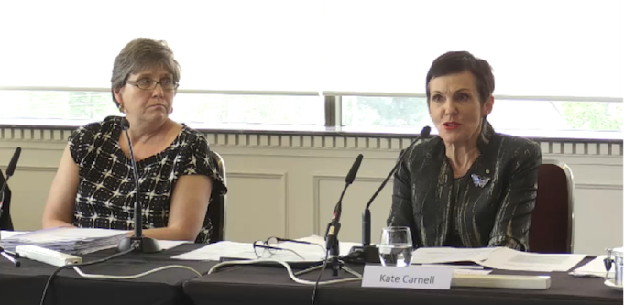
ASBFEO Kate Carnell and Small Business Bank Loans Inquiry Team Leader Anne Scott questioning bank executives during public hearings held in Melbourne.

Website
During the reporting period there were more than 15,000 hits on the ASBFEO website. The majority of those were new visitors.

News Subscriptions
As at 31 December 2016, 1,320 people had subscribed to receive news updates and newsletters though the ASBFEO website.

Social media
As of 31 December 2016, the Ombudsman had 364 Twitter followers, up from 250 in the previous quarter. The ASBFEO is continuing to engage with the sector through other social media platforms, with a specific focus on small business engagement on Facebook.

Media Releases
The ASBFEO published the following media releases/columns during the reporting period.
- 12/10 – Opinion piece (The Australian) Tax cuts key for small firms.
- 18/10 – Join the debate on ‘loaded rates’.
- 27/10 – Time’s up on Superstream sign-on.
- 29/10 – Opinion piece (Sydney Morning Herald) Fair to become the new standard for small biz contracts.
- 1/11 – Opinion piece (Daily Telegraph) Why PPL discriminates against businesswomen.
- 2/11 – TWU trivialise the seriousness of road safety.
- 9/11 – Enhanced protection for small business retailers welcome.
- 9/11 – Helping the little guys get a fairer deal from big business.
- 16/11 – Column: Early trumps late when it comes to payments.
- 16/11 – Payment times inquiry underway.
- 28/11 – Banks to appear at ASBFEO hearings.
- 30/11 – A new era of fairness and productivity.

Key meetings and events
The Ombudsman held a range of meetings throughout the reporting period with small business stakeholders.
The Ombudsman also took part in a range of speaking engagements including but not limited to:
- IAA Audiologists Conference;
- Bizruption – Small Business event;
- King Wood Malleson – Mental Health Panel;
- Small Business Commissioner Meeting;
- Small Business and Franchising Consultative Committee;
- Small Business Stewardship Meeting; and
- Address to Small Business Policy Division Planning Day.

Advocacy

Inquiries
The Ombudsman completed two large referred inquiries during the course of 2016 as well as commenced our first own-self initiated inquiry.

Small Business Loans Inquiry

The Ombudsman completed an inquiry into the adequacy of the law and practices governing authorised deposit taking institutions in lending to small business. The inquiry recommended to Government to help determine if the issues in those cases are now being addressed by current Government and industry reforms, or if additional reform measures should be implemented.

The final report was presented to Small Business Minister, the Hon. Michael McCormack MP on 12 December 2016.

Key findings:
- Since the Global financial crisis in 2009 there have been 17 inquiries and reviews into practices in the financial services sector with more than 40 recommendations made relating to small business and banking practices.
- Issues have been repeatedly raised and recommendations recycled from one inquiry into the next with the banking industry taking little action.
- The banking industry is currently implementing a six-point plan though it is unclear if meaningful reform will be achieved.
- The Code of Banking Practice is self-regulated written in legal terms from the banks’ perspective with small business mixed-in with consumers.
- Property valuation, financial ratios and generalised ‘material adverse change’ clauses are present in small business loan contracts. Notice periods prescribed in clauses and covenants included in small business loan contracts can be disregarded by banks.
- There is no mandatory advance notice to small business should a bank decided to not roll over existing loans. Loan contract documentation is voluminous and legalistic and cannot reasonably be read and comprehend.
- Commercial contracts are the same for a small business borrowing up to $5 million as they are for large corporate business borrowing $100 million. The risks are not.
- No mandatory sharing of valuation instructions, valuation results or valuation methodology with borrowers, despite borrowers paying for valuations. Some banks already do this and some do not.
- There is no consistent or clear practice by banks of providing borrowers with the instructions given to the investigating accountant. This can lead to misunderstanding by the borrower, including why the investigating accountant was appointed.
- There are numerous issues with the external dispute resolution scheme, the Financial Ombudsman Service including a low cap on the amount of a loan which FOS can consider; FOS’ jurisdiction to consider issues relating to receivers, valuers and investigative accountants and the ability of a small business to go to FOS following farm debt mediation.
- Some banks have implemented customer advocates and some have not.

Payment Times and Practices Inquiry
Late payments to small business were a consistent theme in our consultation with small business and family enterprise earlier in 2016. The issue of payment times was also raised in media reports of a number of large corporations extending their payment terms as well as a select number of assistance cases brought to us directly. The inquiry was launched on 16 November 2016.
This inquiry aims to establish a clear view of the trends that have emerged in recent years with a focus on the commercial arrangements between large and small businesses. The Inquiry will assess the impacts these trends are having and will identify practical solutions – including possible regulatory and market-based responses – that can be implemented quickly and effectively to help address identified problem areas.
The Inquiry will seek input from businesses and other industry stakeholders through submissions, an online survey as well as through public consultations, with the final report to be produced by March 2017.

Research and advocacy issues
Over 2016 we undertook advocacy and research across a large number of sectors, industries and topics including:

- Competition and consumer issues
- Procurement
- Access to justice issues
- Immigration
- Banking
- Franchising challenges
- Transport industry
- Wine industry
- Taxation
- Education and Childcare
- Intellectual property
- Travel industry

In the last quarter the Ombudsman undertook has focused on a range of policy areas identified as impacting upon small business and family enterprises. New issues which we examined included:
- Education and Employment: the impact of reforms in the Vocational Educational and Training (VET) sector and the challenges affecting small businesses regarding determining the status of independent contractors versus employees
- Business Information: represented small business concerns regarding the proposed sale of the ASIC corporate registry
- Taxation: issues relating to Goods and Services Tax (GST) for small businesses in the accommodation and hospitality sector including the growing challenge of the sharing economy as well as participating in the ATO fix-it squad on building and construction challenges.
- Dairy industry: the reform challenges within the industry relating to contracting. This included Ombudsman staff appearing as witnesses at the Senate Enquiry into the dairy industry. We also launched a feedback mechanism on our website to collect submissions from participants in the dairy industry.
- Travel industry: researching the effects of recent changes to competition issues in the travel industry for online booking agents and small business using the services
- Industrial Relations: we launched a feedback tool on our website to collect information on the proposal regarding introducing loaded rates to examine issues and potential solution associated with penalty rates.
We also continued advocacy work on:
- Competition and consumer issues: the introduction of the “effects test” in relation to the misuse of market power
- Commonwealth procurement: engaging Defence on above-the-line contracting relating to capability development procurement
- Access to justice issues: contributing to the Ramsay Review into the External dispute resolution in the Financial industry review as well as contributing to the Australian Consumer Law (ACL) review report.
- Practice of banks: outside of the small business loans inquiry we continued work with small business and industry groups on de-risking for small business money remitters

Forward work plan and Small Business Statistics
Both the forward work plan has been finalised. A short public flyer outlining the forward work plan has been prepared to outline the key elements of the forward work plan. The statistical research report entitled “Small Business Counts” was also finalised during the quarter.
The statistical research paper and the forward work plan flyer will be publicly issued in early 2017.

Legislation, policies and practices impacting small business
The Ombudsman participated in a variety of public inquiries and consultation processes involving a wide range of policy topics relevant to small businesses and family enterprises. In the last quarter, the Ombudsman made 11 submissions which commented on various regulatory proposals impacting on Australian small businesses and family enterprises, including (but not limited to):
  - Superannuation reform package;
  - Competition law amendments;
  - The ACCC regarding:
    - decision on South Australian Council Waste Collection application
    - the draft section 46 ‘Effects test’ guidelines
    - the inquiry into the dairy industry
    - the inquiry into new car retailing
  - Defence capability development procurement processes
In total the Ombudsman provided over 30 submissions to advocate for small business and family enterprise issues throughout 2016.

Assistance
During the reporting period, the Ombudsman received 493 contacts through phone and email, the large majority of these being dispute related matters or enquiries in relation to the Small Business Loans and Payment Times and Practices Inquiries. Figure 1 below represents a breakdown.

As seen in Figure 2 below, from the 309 dispute contacts that the Ombudsman received, the majority were in relation to business-to-business disputes.

Figure 3 below identifies who is contacting the Ombudsman – the majority of the contacts are made by small business owners. The Ombudsman also received a number of consumer complaints that were referred to either the ACCC or the Fair Trading office in the relevant State.

Of the 493 contacts made to the Ombudsman’s office during this period, the vast majority of them where made from small businesses located in New South Wales, Queensland and Victoria. Where the Ombudsman is not able to provide assistance, the small businesses are referred to the relevant Small Business Commissioner or a state based dispute resolution mechanism (as per Figure 5).
Figure 4

Figure 5

Examples of Assistance Provided

Payment Times and Practices Inquiry
Approximately 30 per cent of the requests for assistance the ASBFEO receive are in relation to non-payment or late payment of invoices. The ACCC recently referred a matter to our office where the small business required assistance with late payment of invoices.
The matter involved a newsagency that supplied Coles and Woolworths petrol stations with newspapers. The newsagency invoiced Coles and Woolworths weekly, however over the past 2 years the accounts had often gone unpaid outside the agreed timeframes, and usually by several months.
The Ombudsman’s office contacted the Managing Directors of both Woolworths and Coles seeking their assistance with this matter. Coles responded to the Ombudsman’s correspondence and took immediate action to pay the outstanding balances to the newsagency. Coles conducted a full investigation into the previous missed payments and have now put measures in place with the small business owner to ensure that invoices are received immediately via fax and are process by the accounts team as soon as received.
At the time of writing this report, the Ombudsman’s office had not received a response from Woolworths and were following them up.

Business-to-Business Disputes
A small business owner contacted the Ombudsman’s office to request assistance with a dispute concerning advertising fees with Sensis. They believed they had been charged for advertising during 2016/17 for advertising that they had not agreed on. The small business owner was not aware that there was an automatic renewal clause within the contract with Sensis.
The small business owner had been a customer with Sensis for over 30 years and each year a Sensis representative would visit their store to discuss the advertising fees and review the advertisement before they would then sign the agreement for another twelve month period. In 2015, the small business owner did not receive any contact from Sensis nor signed any further agreement with them, therefore assumed there would be no further fees.
The Ombudsman’s office contacted Sensis requesting that they look into this matter and seeking their comments to assist with our enquiry. Through this process, the Ombudsman’s office was able to get Sensis to agree to cancel the advertising contract immediately and waiver any cancellation fees. The small business owner was only required to pay for the advertising that had already taken place.

Assistance contacts received in 2016
Since its inception on 11 March, the Ombudsman’s office received 2,021 requests for assistance either by phone or email for the year 2016. Figures 6 - 10 below represents a breakdown of these contacts.
Figure 6 – Type of Contact

Figure 7 – Type of Dispute

Figure 8 – Identity of Contact

Figure 9 – Contacts by State & Territory

Figure 10 – Referral of Disputes

